O365 Integration into Snow EM - Inbound Action – Action is where the O365_Snow_InboundActionScript.js data is pasted in.

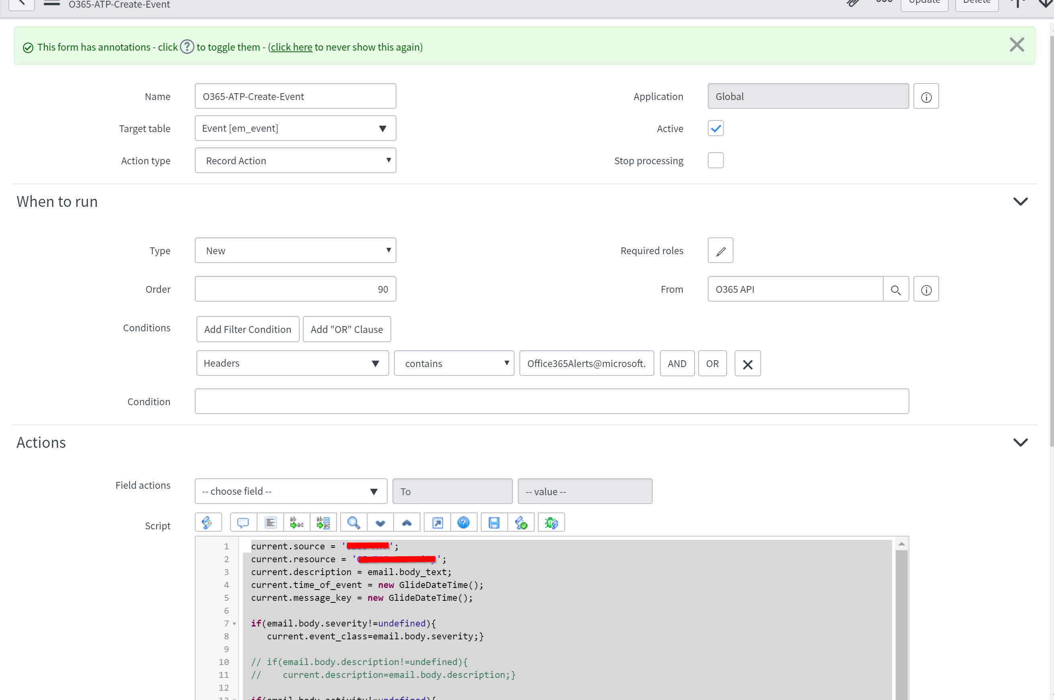

Event Rules – (Note I am mapping Severity to Source Instance since there is an Image before the Severity Word).

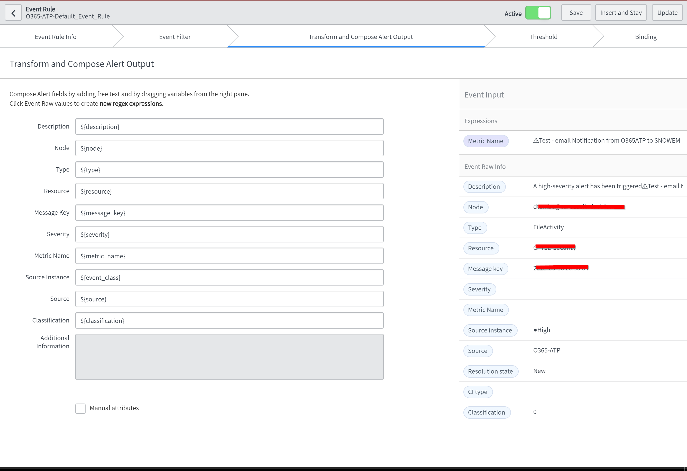

Event Field Mappings – (This is important since we are passing original values to Source Instance. We need to convert them to ServiceNOW severity and map it to Severity field.

